Appendix-II

Ref. No. UCVLLP/ PNB/2025-26/468 Date: 04/08/2025

VALUATION REPORT OF
RAJ NITIN SHAH & MOKSHA RAJ SHAH
At
FLAT NO. 4901, 49TH FLOOR, EAST WING, THE WORLD CREST, SENAPATI BAPAT MARG. CS NO. 443, 444, 445(PT), 446 OF VILLAGE LOWER PAREL, MUMBAI 400013
FOR
PNB, LALBAUG BRANCH

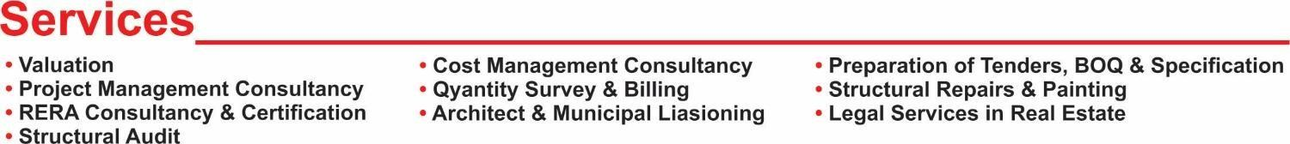

PUNJAB NATIONAL BANK, LALBAUG BRANCH

VALUATION REPORT (IN RESPECT OF FLAT)

SR.NO | Particulars | Content
I | GENERAL
 | Name & address of the Valuer
2. | Purpose for which the valuation is made
3. | a) Date of inspection
 | b) Date on which the valuation is made
4. | List of documents produced for perusal
 | - Agreement for Sale
 | - Part Occupancy Certificate
 | - Index II
 | - Other Documents
5. | Name of the owner(s) and his / their address (es)  With Phone no. (details of share of each owner in  case of joint ownership) | Owner:  Contact No.:  Ownership:
6. | Brief description of the property
7. | Location of property
 | - Plot No. / Survey No.
 | - Door No.
 | - C. T. S. No. / Village
 | - Ward / Taluka
 | - Mandal / District
 | - Date of issue and validity of layout of approved map / plan
 | - Approved map / plan issuing authority
 | - Whether genuineness of authority of approved map / plan is verified
 | - Any other comments on authentic of approved plan
 | - Comment on unauthorized construction if any
 | - Comment on demolition proceedings if any
8. | Postal address of the property
9. | City / Town
 | Residential Area
 | Commercial Area
 | Industrial Area
10. | Classification of the area
 | i) High / Middle / Poor
 | ii) Urban / Semi Urban / Rural
11. | Coming under Corporation limit / Village Panchayat / Municipality
12. | Whether covered under any State / Central Govt. Enactments (e.g. Urban Land Ceiling Act) or notified under agency area / scheduled area / cantonment area
13. | Boundaries of the property | (As per Site) | (As per Flat)
 | East
 | West
 | North
 | South
14. | Dimensions of the site / Flat | A | B
 |  | As per the Deed | Actuals
15. | Extent of the site
15.1 | Latitude, Longitude, & Co-ordinates of Flat
16 | Extent of the site considered for valuation (least of 13A & 13B)
17 | Whether occupied by the owner / tenant? If occupied by tenant, since how long?
II. | FLAT
1. | Name of the Apartment
2. | Description of the locality  Residential / Commercial / Mixed
3. | Year of Construction
4. | Number of Floors
5. | Type of Structure
6. | Number of Dwelling flats
7. | Quality of Construction
8. | Appearance of the Flat
9. | Maintenance of the Flat
10. | Facilities Available
 | Lift
 | Protected Water Supply
 | Underground Sewerage
 | Car Parking – Open / Covered
 | Does Compound wall exist?
 | Is pavement laid around the Flat?
III | FLAT
1 | The floor on which the Flat is situated
2 | Door No. of the Flat
3 | Specification of the Flat
 | Roof
 | Flooring
 | Doors
 | Windows
 | Fittings
 | Finishing
4 | House Tax
 | Assessment No.
 | Tax paid in the name of
 | Tax amount
5 | Electricity Service Connection no.
 | Meter Card is in the name of
6 | How is the maintenance of the Flat?
7 | Sale Deed executed in the name of
8 | What is the undivided area of land as per Sale Deed?
9 | What is the plinth area of the Flat?
10 | What is the floor space index (app.)
11 | What is the Carpet & Built-up Area of the Flat?
12 | Is it Posh/ I class / Medium / Ordinary?
13 | Is it being used for Residential or Commercial Purpose?
14 | Is it Owner-occupied or let out?
15 | If rented, what is the monthly rent?
IV | MARKETABILITY
1 | How is the marketability?
2 | What are the factors favouring for an extra Potential Value?
3 | Any negative factors are observed which affect the Market value in general?
V | Rate
1 | After analysing the comparable sale instances, what is the composite rate for a similar flat with same Specifications in the adjoining locality?
2 | Assuming it is a new construction, what is the  adopted basic composite are of the flat under valuation after comparing with the specifications and other factors with the flat under comparison (give details).
3 | Break-up for the rate
 | i) Flat + Services
 | ii) Land + Others
4 | Guideline rate obtained from the Registrar’s office (an Evidence thereof to be enclosed)
VI | COMPOSITE RATE ADOPTED AFTER DEPRECIATION
a. | Depreciation Flat rate
 | Replacement cost of Flat with Services (v (3)i)
 | Age of the Flat
 | Life of the Flat estimated
 | Depreciation percentage assuming the salvage values 100%
 | Depreciated Ratio of the Flat
b. | Total composite rate arrived for valuation
 | Depreciated Flat rate VI (a)
 | Rate for Land & other V (3) ii
 | Total Composite Rate

Details of Valuation:
Sr. No | Description | Built up Area | Rate per sq. ft.  (Rs. / sq. ft.) | Estimated Value Rs.
1 | Present value of the Flat No. 4901 | 2825 | 48,000/- | Rs. 13,56,00,000/-
2 | Car Parking | 3 | Rs. 15,00,000/- | Rs. 45,00,000/-
3 | Summary of Value |  |  | Rs. 14,01,00,000 /-

Remarks:
- Report finalized based on site visit and copy of Agreement for sale, Part OC, Index II, Share Certificate, Property Tax, etc. However, we have not been Provided, C.C., Typical Floor Plan, Approved plan, Electricity Bill, title report, etc. for Verification Purposed.
- The said property is owner occupied at the time of visit.
- Flat number was displayed on main entrance door.
- The said property is situated in residential area.
- Property is inspected as shown by Mrs. Moksha (Owner).
- We consider the area given in the Agreement for sale/Index II declared by the party and submitted for registration with the government authorities as final for valuation purpose. Any area that is not stated in the Agreement for sale/Index II is not considered for valuation unless the area is measured by us in which case that may be considered for valuation purpose.
- The scope of our valuation work is only for banks financial/loan purpose. Further, please be noted that this report shall not be used for any litigation purpose.
- Encumbrance of Loan, Government and other dues, stamp duty, registration charges, transfer charges etc, if any are not considered in the valuation. We assumed that the assets are free from encumbrance unless otherwise stated to us by the party in writing.
- The value given in our report is the estimate of the Fair Market value of the property as on date, considering various aspects of the property as mentioned above.

As a result of my appraisal and analysis, it is my considered opinion that the present market value of the Above property in prevailing condition with aforesaid specifications is value Rs. 14,01,00,000/- (Rupees Fourteen Crore One Lakh Only)

1 | Fair Market Value of immovable property:
2 | Realizable Value of immovable property: (90%)
3 | Distress Sale Value of immovable property: (80%)
4 | Guideline Value (value as per Circle Rates),  if applicable, in the area where immovable property is situated
5 | Insurance Value
6 | Date of purchase of immovable property:
7 | Purchase Price of immovable property:

Place: Thane
Date: 04/08/2025

Manoj Kumar Sharma
B.E (Civil), F.I.V., M.I.E
Govt. Regd. Valuer
Panel Valuer of Punjab National Bank
(IBBI/RV/07/2019/11044)

I hereby declare that:
- The information furnished is my valuation report dated 04/08/2025 is true and correct to the best of my knowledge and belief and I have made an impartial and true valuation of the property.
- I have no direct or indirect interest in the property valued.
- Our Engineer Mr. Jitendra Bhagat has inspected the property on 02/08/2025.
- I have not been convicted of any offence and sentenced to a term of imprisonment.
- I have not been found guilty of misconduct in my professional capacity.
- I have read the Handbook on Policy Standards and procedure for Real Estate valuation, 2011 of the IBA and this report is in conformity to the “Standard” enshrined for valuation in the Part-B of the above handbook to the best of my ability.
- I have Read the International Valuation Standards (IVS) and the report submitted to the Bank of the respective asset class is in conformity to the “Standard” as enshrined for valuation in the IVS in “General standard” and “Asset Standards” as applicable.
- I abide by the Model Code of Conduct for empanelment of valuer in the Bank. (Annexure III-A signed Copy of Same to be taken and kept along with this declaration).
- I am registered under Section 34 AB of the Wealth Tax Act, 1957.
- I am the proprietor / partner / authorized official of the firm / company, who is competent to sign this valuation report.
- Further, I hereby provide the Following information.
Sr. No. | Particulars | Valuer comment
 | Background information of the asset being valued;
 | Purpose of valuation and appointing authority
 | Identity of the valuer and any other experts involved in the valuation;
 | Disclosure of valuer interest or conflict, if any;
 | Date of appointment, valuation date and date of report;
 | Inspections and/or investigations undertaken;
 | Nature and sources of the information used or relied upon;
 | Procedures adopted in carrying out the valuation and valuation standards followed;
 | Restrictions on use of the report, if any;
 | Major factors that were taken into account during the valuation;
 | Major factors that were not taken into account during valuation;
 | Caveats, limitations and disclaimers to the extent they explain or elucidate the limitations faced by valuer, which shall not be for the purpose of limiting his responsibility for the valuation report.

MODEL CODE OF CONDUCT FOR VALUERS
{Adopted in line with Companies (Registered Valuers and Valuation Rules, 2017)}
All valuers empanelled with bank shall strictly adhere to the following code of conduct:
Integrity and Fairness
1. A valuer shall, in the conduct of his/its business, follow high standards of integrity and fairness in all his/its dealings with his/its clients and other valuers.
2. A valuer shall maintain integrity by being honest, straightforward, and forthright in all professional relationships.
3. A valuer shall endeavour to ensure that he/it provides true and adequate information and shall not misrepresent any facts or situations.
4. A valuer shall refrain from being involved in any action that would bring disrepute to the profession.
5 A valuer shall keep public interest foremost while delivering his services.
Professional Competence and Due Care
6. A valuer shall render at all times high standards of service, exercise due diligence, ensure proper care and exercise independent professional judgment.
7. A valuer shall carry out professional services in accordance with the relevant technical and professional standards that may be specified from time to time
8. A valuer shall continuously maintain professional knowledge and skill to provide competent professional service based on up-to-date developments in practice, prevailing regulations/guidelines and techniques.
9. In the preparation of a valuation report, the valuer shall not disclaim liability for his/its expertise or deny his/its duty of care, except to the extent that the assumptions are based on statements of fact provided by the company or its auditors or consultants or information available in public domain and not generated by the valuer.
10. A valuer shall not carry out any instruction of the client insofar as they are incompatible with the requirements of integrity, objectivity and independence.
11. A valuer shall clearly state to his client the services that he would be and competent to provide the services for which he would be relying on other valuers or professionals or for which the Independence and Disclosure of Interest.
12. A valuer shall act with objectivity in his/its professional dealings by ensuring that his/its decisions are made without the presence of any bias, conflict of Interest, coercion, or undue influence of any party, whether directly connected to the valuation assignment or not.
13. A valuer shall not take up an assignment If he/it or any of his/its relatives or associates is not independent in terms of association to the company.
14. A valuer shall maintain complete independence in his/its professional relationships and shall conduct the valuation Independent of external influences.
15. A valuer shall wherever necessary disclose to the clients, possible sources of conflicts of duties and interests, while providing unbiased services.
16. A valuer shall not deal in securities of any subject company after any time when he/it first becomes aware of the possibility of his/its association with the valuation, and in accordance with the Securities and Exchange Board of India (Prohibition of Insider Trading) Regulations, 2015 or till the time the valuation report becomes public, whichever is earlier.
17. A valuer shall not indulge in "mandate snatching" or offering "convenience valuations" in order to cater to a company or client's needs.
18. As an independent valuer, the valuer shall not charge success fee (Success fees may be defined as a compensation incentive paid to any third party for successful closure of transaction. In this case, approval of credit proposals).
19. In any fairness opinion or independent expert opinion submitted by a valuer, if there has been a prior engagement in an unconnected transaction, the valuer shall declare the association with the company during the last five years.

Confidentiality
20. A valuer shall not use or divulge to other clients or any other party any confidential information about the subject company, which has come to his/its knowledge without proper and specific authority or unless there is a legal or professional right or duty to disclose.
Information Management
21. A valuer shall ensure that he/ it maintains written contemporaneous records for any decision taken, the reasons for taking the decision, and the information and evidence in support of such decision. This shall be maintained so as to sufficiently enable a reasonable person to take a view on the appropriateness of his/its decisions and actions.
22. A valuer shall appear, co-operate and be available for inspections and investigations carried out by the authority, any person authorised by the authority, the registered valuers organisation with which he/it is registered or any other statutory regulatory body.
23. A valuer shall provide all information and records as may be required by the authority, the Tribunal, Appellate Tribunal, , the registered valuers organisation with which he/it is any registered, u other statutory regulatory body.
24. A valuer while respecting the confidentiality of information performing professional acquired during the course of services, shall maintain proper working papers for a period of three years or such longer period as required in its contract for a specific valuation, for production before a regulatory authority or for a peer review. In the event of a pending case before the Tribunal or Appellate Tribunal, the record shall be maintained till the disposal of the case.
Gifts and hospitality:
25. A valuer or his/its relative shall not accept gifts or hospitality which undermines or affects independence as a valuer.
Explanation. - For the purposes of this code the term 'relative' shall have the same meaning as defined in clause (77) of Section 2 of the Companies Act, 2013 (18 of 2013)
26. A valuer shall not offer gifts or hospitality or a financial or any other advantage to a public servant or any other person with a view to obtain or retain work for himself/ itself, or to obtain or retain an advantage in the conduct of profession for himself/ itself.
Remuneration and Costs.
27. A valuer shall provide services for remuneration which is charged in a transparent manner, is a reasonable reflection of the work necessarily and properly undertaken and is not inconsistent with the applicable rules.
28. A valuer shall not accept any fees or charges other than those which are disclosed in a written contract with the person to whom he would be rendering service.
Occupation, employability and restrictions.
29. A valuer shall refrain from accepting too many assignments, if he/it is unlikely to be able to devote adequate time to each of his/ its assignments.
30. A valuer shall not conduct business which in the opinion of the authority or the registered valuer organisation discredits the profession.

Photographs of the Property
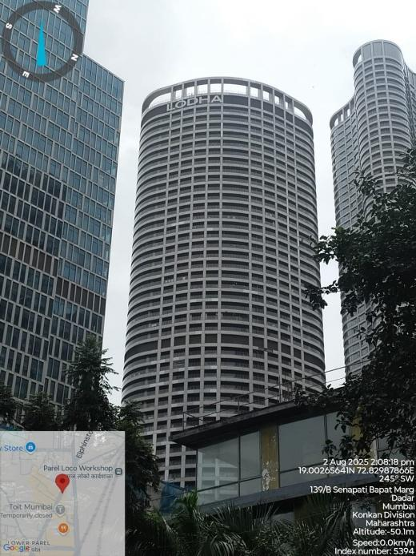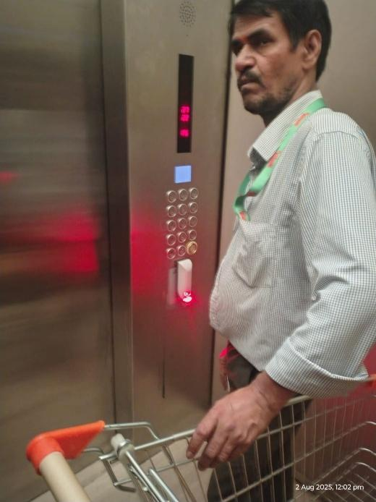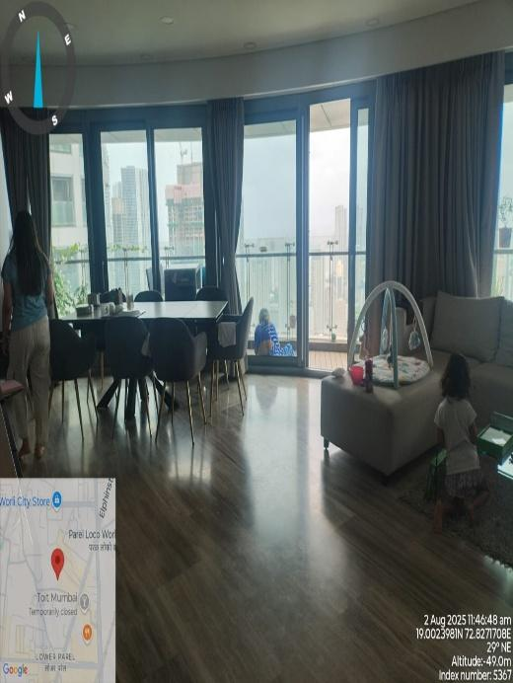
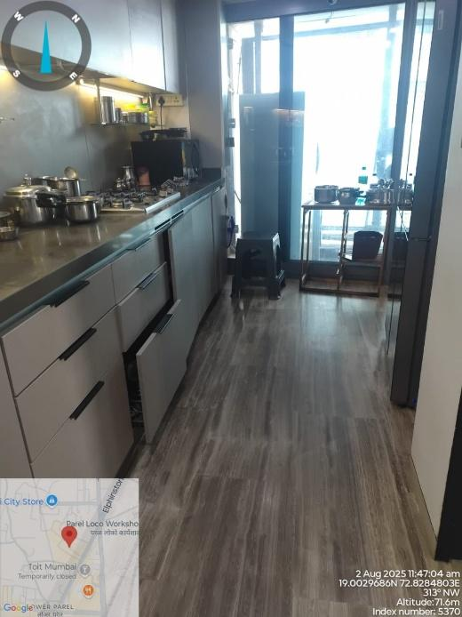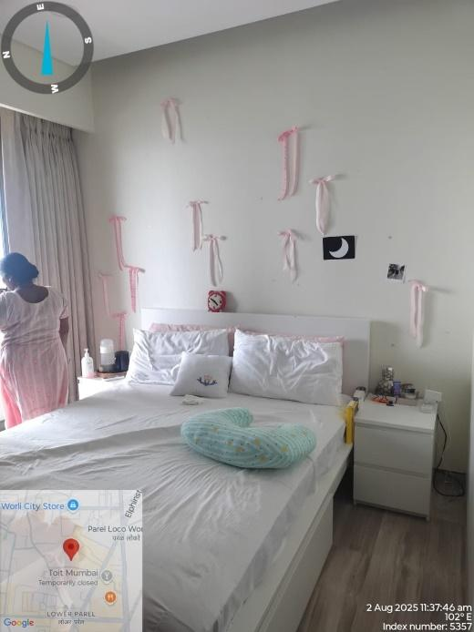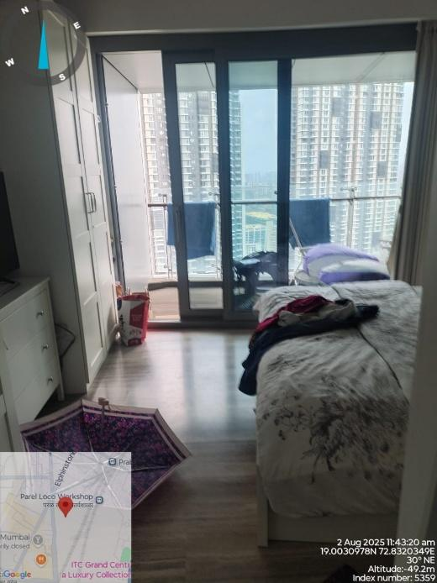
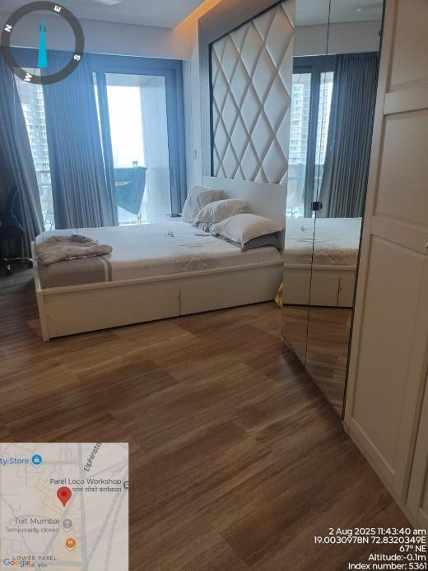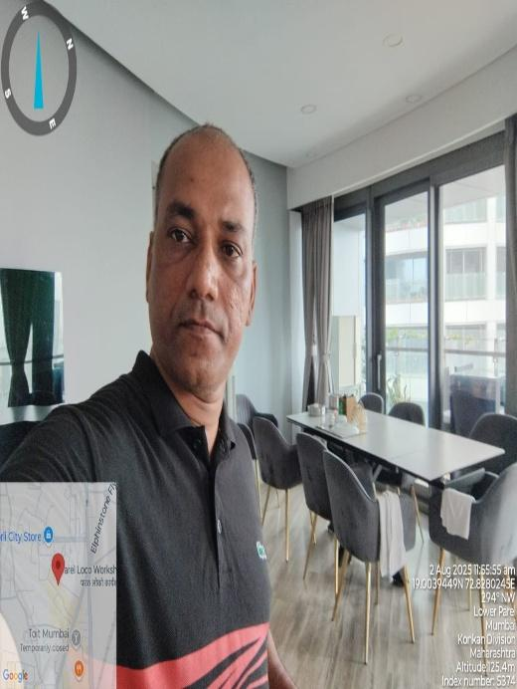
LOCATION MAP
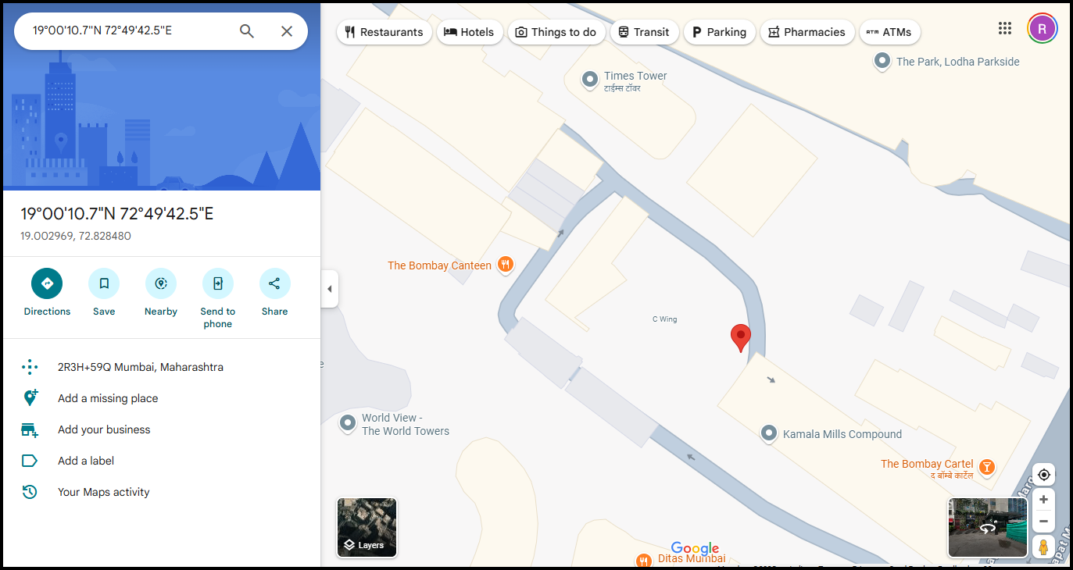
GOVT. READY RECKONER RATE 2025-26
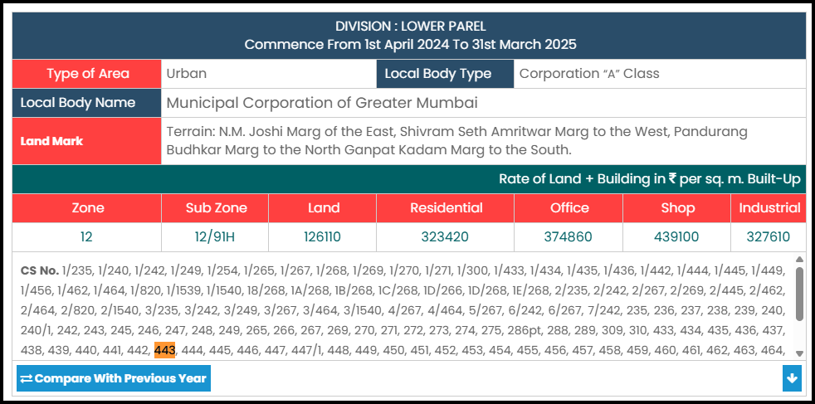
Comparable
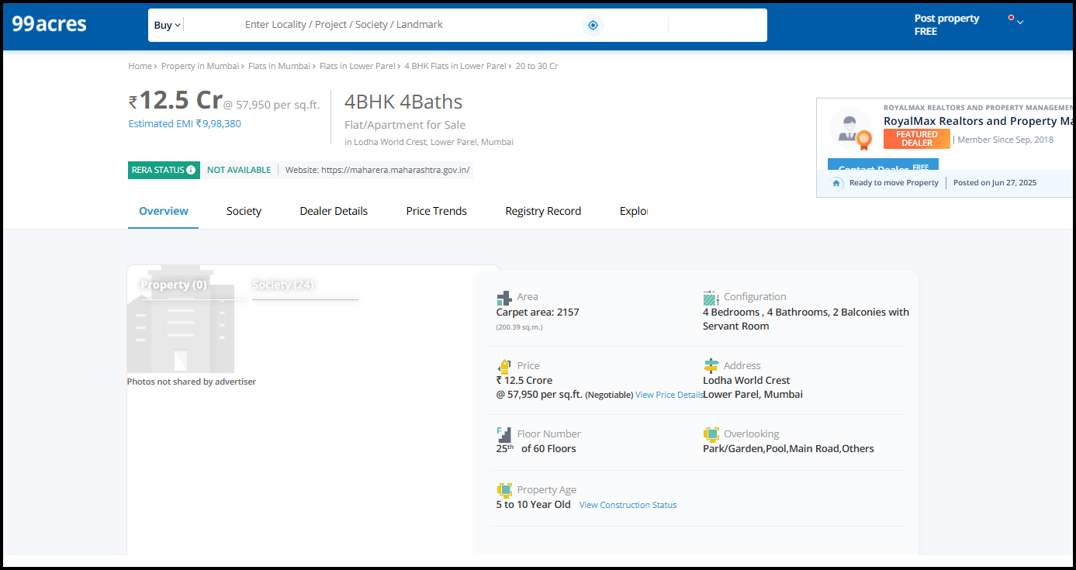
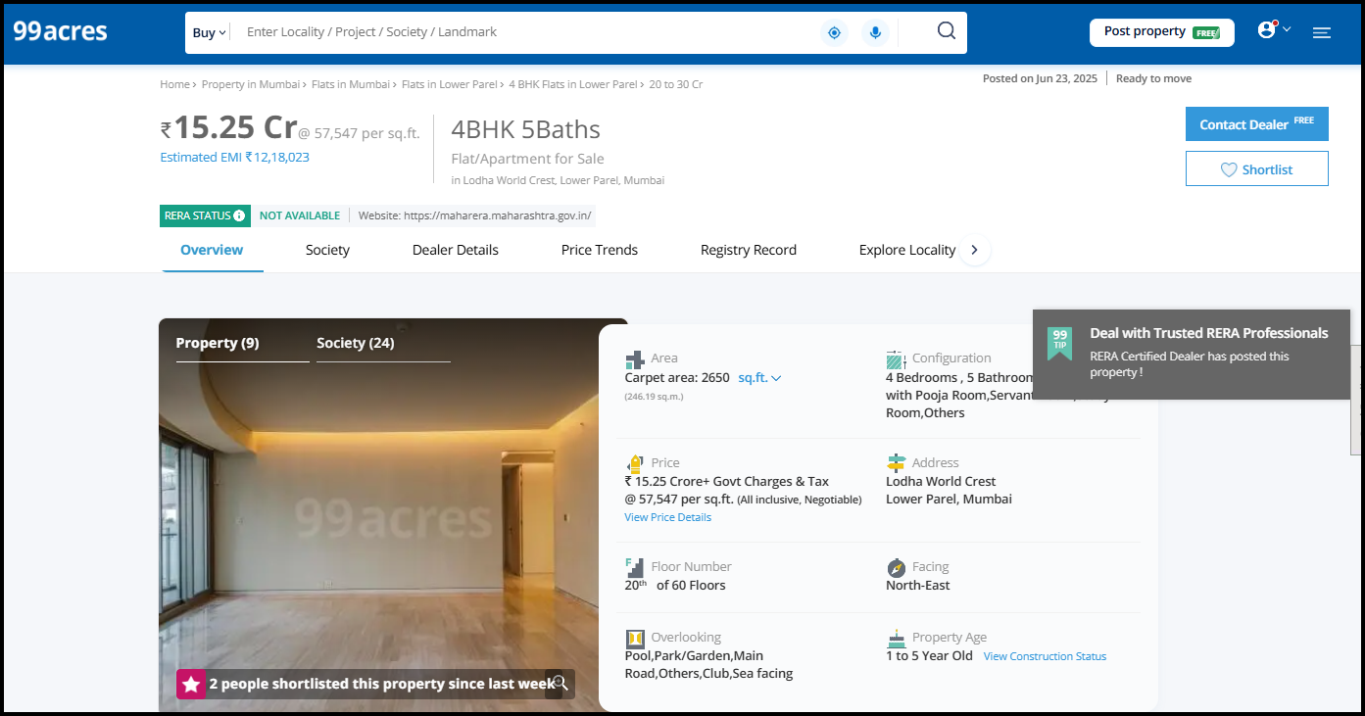
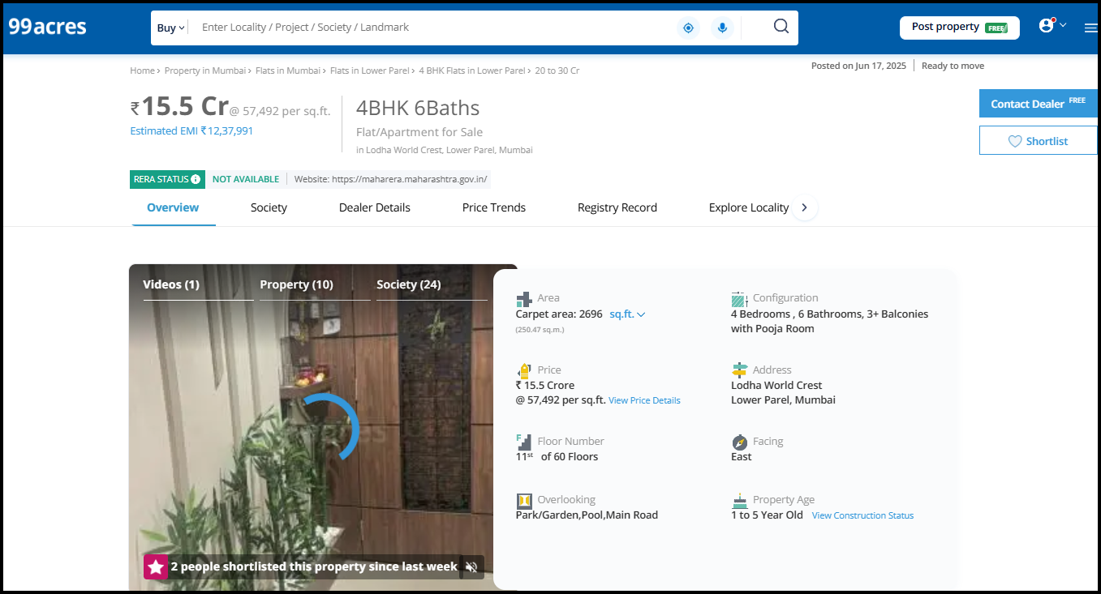
PROPERTY DOCUMENT
